**Old otp_enc**

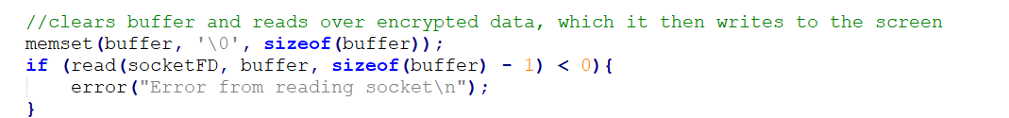

**Revised otp_enc**

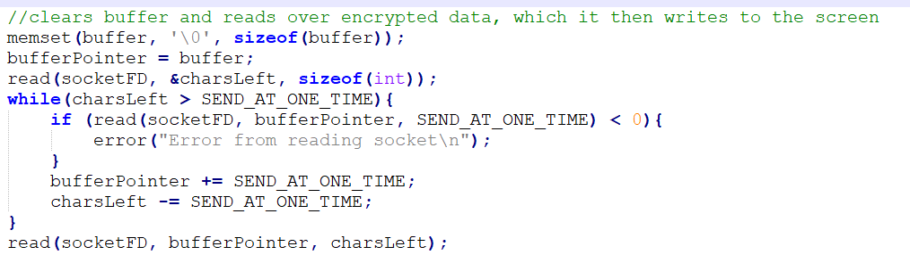

**Old otp_enc_d**

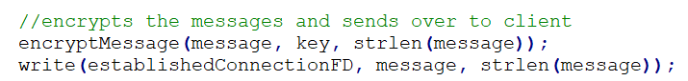

**Revised otp_enc_d**

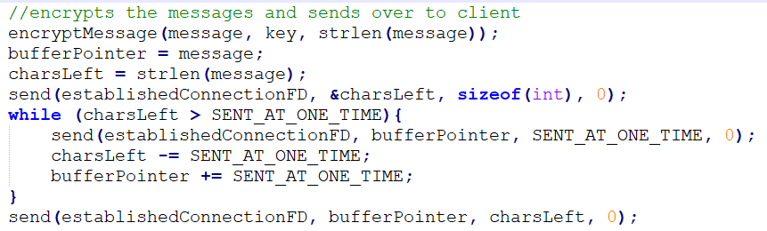

**Old otp_dec**

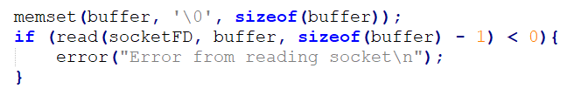

**Revised otp_dec**

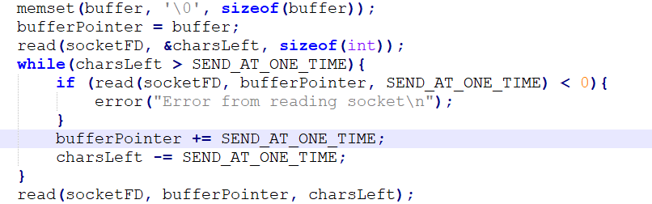

**Old otp_dec_d**



**Revised otp_dec_d**

